June 23, 2010

Planning Report PDS-10-051

Report To: Planning Advisory Committee

Subject: Niagara-on-the-Green Subdivision (Phase 2) 26-28 Haynes Court
Lot 49, Plan 30M-364
Release of Lands from Part Lot Control

1. Recommendation
It is respectfully recommended that:

1.1 the Part Lot Control By-law attached to Planning Report PDS-10-051 (Appendix “B”) to remove ‘Part Lot Control’ from Lot 49 of Plan 30M-364 be forwarded to Town Council for approval.

2. Purpose / Proposal
An application has been submitted to the Planning and Development Services Department for Council to pass a Part Lot Control By-law to remove ‘Part Lot Control’ from Lot 49 of Plan 30M-364 to permit the individual dwelling units to be sold.

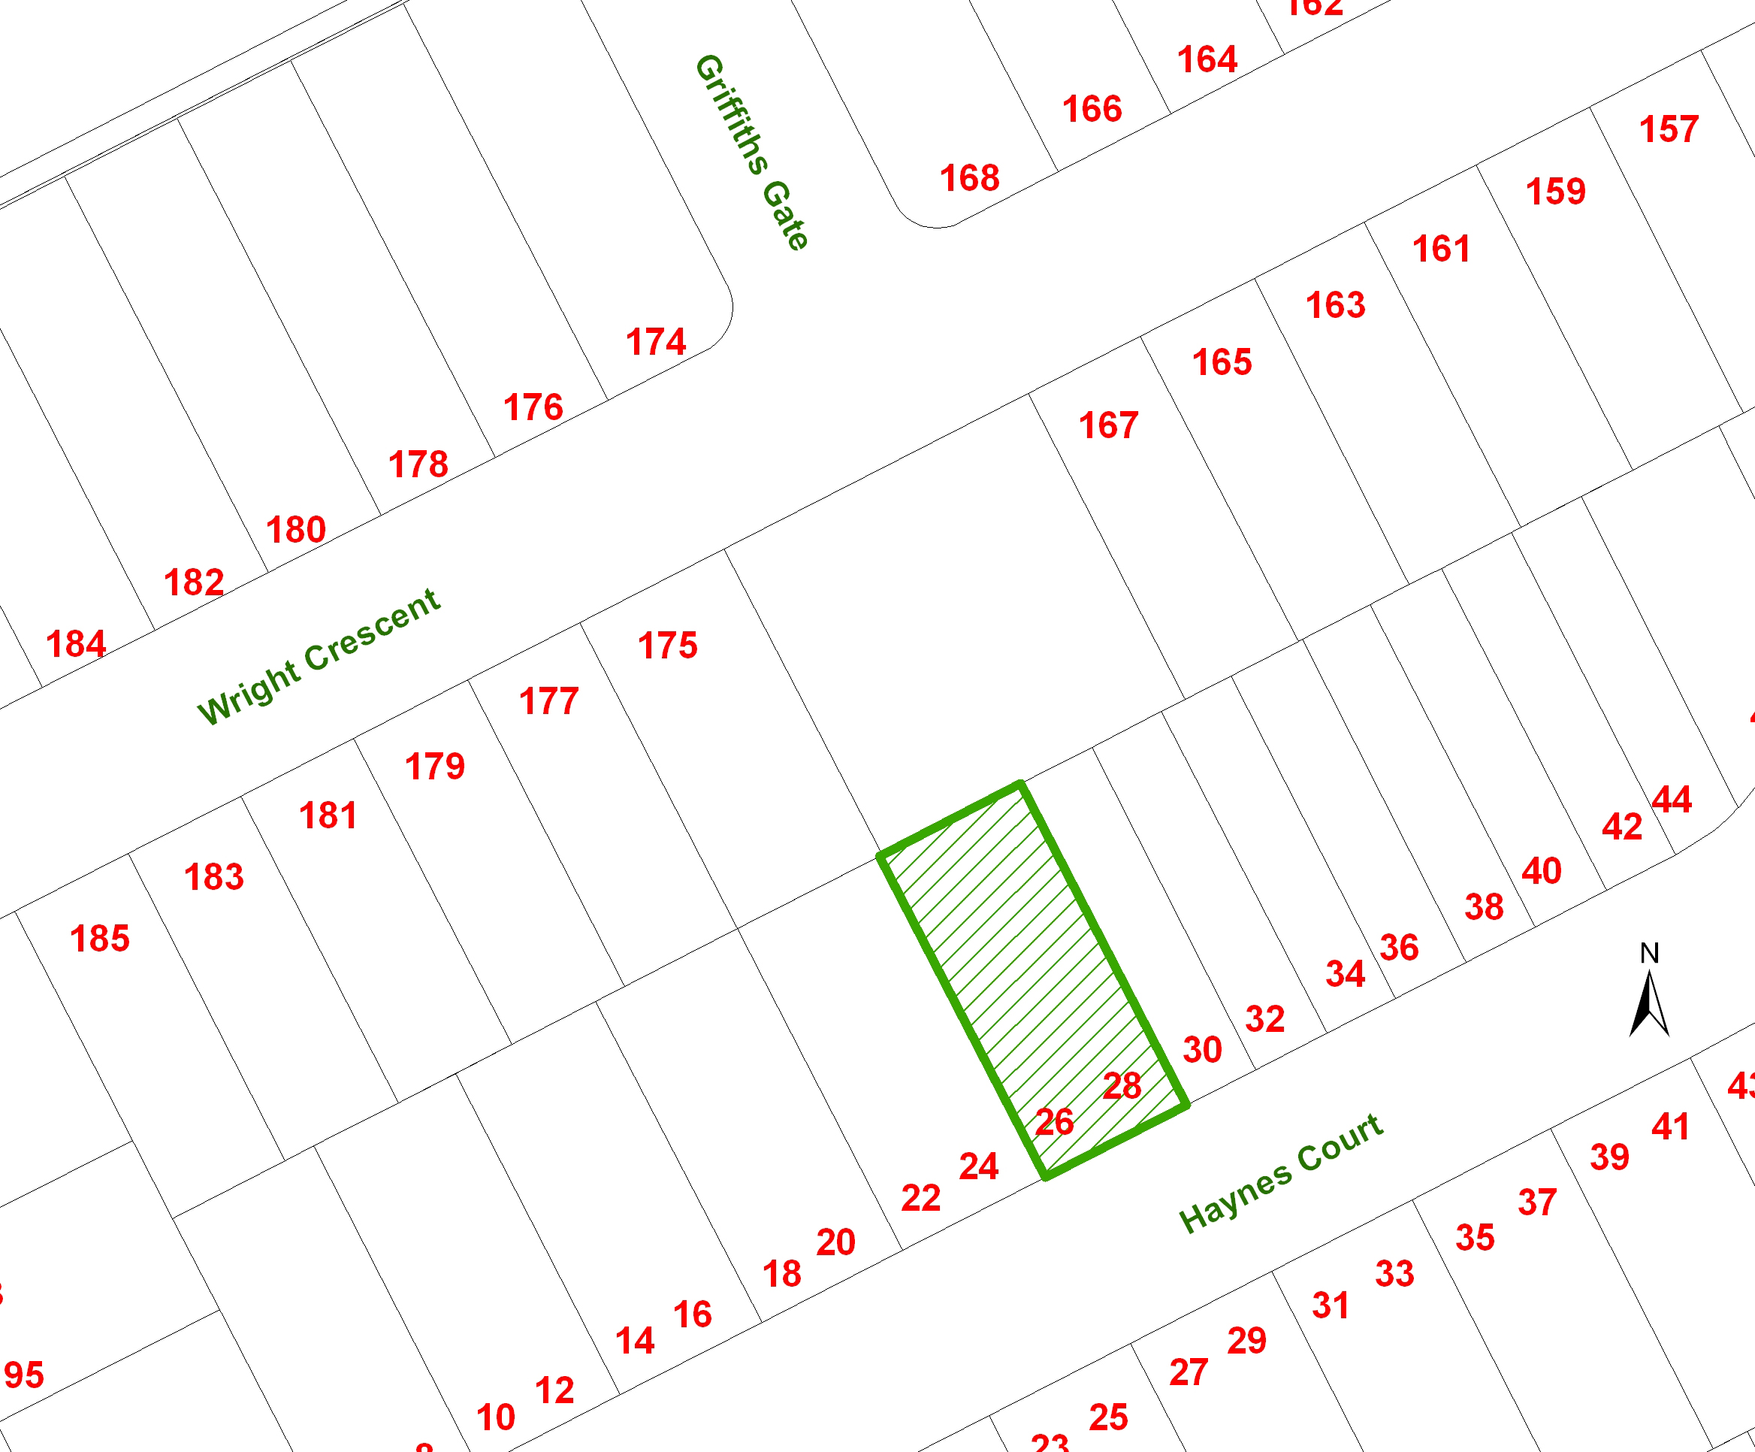

Portion of Plan 30M-364 showing the subject lot.

3. Background
Subdivision Plan 30M-364 was registered on October 31, 2006 and applies to the second phase of the subdivision development known as Niagara-on-the-Green. The lot that is the subject of this application has a semi-detached dwelling that has been constructed and in order to sell these individually, a part lot control by-law must be approved and registered on title.

4. Discussion / Analysis
Section 50, Subsection 5 (Part Lot Control) of the Planning Act, S.O. 1990, provides that where land is within a plan of subdivision, no person shall convey a part of any lot or block. In order to allow the owner to sell the individual residential units and their surrounding lands, a by-law must be enacted pursuant to Section 50, Subsection 7 to lift ‘Part Lot Control’.

Submitted with the application is a registered plan prepared by J. D. Barnes Limited that is 30R-13520 (Lots 49) dated May 28, 2010 which shows the location of the semi-detached dwelling. This is attached as Appendix A. A review of the plan indicates that the building location complies with Zoning By-law 500A-74, as amended, and further amended by By-law 500KH-96, 500TE-06 and 500TS-07.

A draft by-law to remove Lot 49 of 30M-364 from ‘Part Lot Control’ has been prepared for the Planning Advisory Committee’s consideration and is attached as Appendix “B”.

5. Financial Implications
None

6. Communications / Next Steps
Once the Part Lot Control By-law has Council’s approval, it can be registered on title.

7. Conclusion
The semi-detached dwelling is being constructed in accordance with the applicable requirements of the Zoning By-law. The approval of the Part Lot Control By-law will permit the owner to sell the individual semi-detached units.

Written by: Respectfully submitted:

Darka Jensen Barbara Wiens, MCIP, RPP
Zoning Clerk Principal Planner

Stephen Bedford, MCIP, RPP Mike Galloway
Director, Planning & Development Services Chief Administrative Officer

Roll No: 018-083-98

