**Planning Analysis**

**Fiorucci Estates Subdivision – Application for Zoning By-law Amendment**

The proposal is to amend the site specific zoning for Lots 1, 2, 7, 8, 9, 10, 11, 13, 15, 16, 17, 18, 32, 33 and 34 on Registered Plan 30M-397 of Fiorucci Estates (Section 9.13.16.1 (h), R1-16) from a maximum lot coverage of 33%, including accessory buildings, to a maximum lot coverage of 40%, including accessory buildings. Town Staff propose that the site specific zoning for Fiorucci Estates as a whole (Section 9.13.16.1 (h), R1-16) be amended from the maximum lot coverage of 33%, including accessory buildings, to a maximum lot coverage of 37%, including accessory buildings, without attached covered porch and deck, and a maximum lot coverage of 40%, including accessory buildings, and with attached covered porch and deck.

This Planning Analysis is intended to be read as an appendix to the Community and Development Advisory Committee report, dated December 8, 2014, for Fiorucci Estates Subdivision – Application for Zoning By-law Amendment (hereby referred to as the ‘’CDS Report”).

**PLANNING FRAMEWORK**

Provincial and Region Policy

The proposal is consistent with all Provincial and Regional policies.

Town of Niagara-on-the-Lake Official Plan Policy

The proposal is consistent with all Official Plan policies. Proposed developments will be subject to St. Davids Urban Design Guidelines, as discussed in Section 4.4 of the Official Plan.

**COMMENTS**

Circulation

The application was circulated to Town departments and outside agencies. No objections were received. For a summary of the comments, please refer to Appendix C to the CDS Report.

Public Information Meeting

A Public Information Meeting will be held on December 8, 2014; no adverse comments from the public are anticipated with respect to this application.

**PLANNING ANALYSIS**

The applicant is proposing to amend the Zoning By-Law (Section 9.13.16 (h), R1-16) to allow for a maximum lot coverage of 40% for all buildings, up from the currently allowable 33% maximum lot coverage for all buildings for Lots 1, 2, 7, 8, 9, 10, 11, 13, 15, 16, 17, 18, 32, 33 and 34 on Registered Plan 30M-397 (Fiorucci Estates).

The proposed Zoning By-Law Amendment is to amend the site specific zoning for all lots contained in Fiorucci Estates (Section 9.13.16.1 (h), R1-16) from a maximum lot coverage of 33% for all buildings to a maximum lot coverage of 37% for all buildings without attached covered porch and deck, and a maximum lot coverage of 40% for all buildings with attached covered porch and deck.

The proposed amendment would increase the consistency between the required setbacks for R1-16 and the maximum allowable lot coverage. It also has the potential to encourage high quality design that is consistent with the St. Davids Urban Design Guidelines, and ensure that an adequate amount of amenity space can be provided.

A number of minor variance applications have been received by the Town of Niagara-on-the-Lake Community and Development Services Department with respect to increasing the maximum allowable lot coverage of Fiorucci Estates properties, which have generally been granted an increased lot coverage of approximately 36% (between 35.8 and 36.3%) for the dwelling. Meeting the St. Davids Urban Design Guidelines, and providing adequate amounts of amenity space have been cited as reasons for approval of these applications. Community and Development Services has been supportive of these applications. The Town of Niagara-on-the-Lake Zoning By-Law 4316-09, as amended, for St. Davids, generally provides for a maximum allowable lot coverage of between 33 and 50%.

In conducting the site visit to evaluate this planning application, Town Staff visited 1, 8, 28, and 33 Angels Drive, each of which received minor variances for increased maximum allowable lot coverage, as discussed above. From the streetscape the approved increased maximum allowable lot coverage did not appear to have negative, or even discernible impacts on the character of the neighbourhood.

The Town of Niagara-on-the-Lake Zoning By-Law generally appears to allow a difference in lot coverage of five (5) percent in favour of properties with attached covered and/or enclosed porches when maximum lot coverage is approximately 40% where specified. For example, this difference is seen at Emerald Estates Subdivision (Section 9.13.20.2), located within St. Davids. However, given the extent of the proposed increase, interest in strengthening the St. Davids Urban Design Guidelines, and lack of differentiation in terms of maximum allowable lot coverage for Fiorucci Estates between bungalows and 1 ½ storey dwellings and 2 storey dwellings, a maximum lot coverage of 37% including accessory buildings without attached covered porch and deck, and a maximum lot coverage of 40% including accessory buildings with attached covered porch and deck for lots contained in Fiorucci Estates has been proposed by staff. These values were approved of for Vineyards Annex Subdivision, located in Virgil (Section 10.12.8.5), and appear to have encouraged quality urban design with sufficient amounts of amenity space.

Including all lots contained in the Fiorucci Estates subdivision in the proposed Zoning By-Law Amendment is not anticipated to negatively impact the residents and owners of the subdivision, or minor variances already approved of for a number of properties within the subdivision. It will increase the flexibility that property owners have with regard to their lot coverage, may reduce the need for future minor variance applications for properties within the subdivision, and represents a simplification from the Zoning By-Law Amendment that was proposed. Town Staff could not identify a planning rationale for the approval of increased maximum lot coverage for over 50% of lots contained within the subdivision (including lots with approved minor variances for increased maximum lot coverage), without including all of them. The inclusion of all lots was therefore deemed to be most appropriate from a planning perspective.

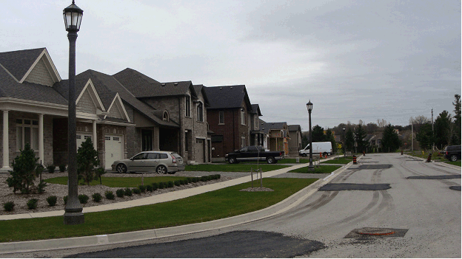

**Figure 1.**

**View of a typical portion of the Fiorucci Estates Subdivision along Angels Drive, looking south.**

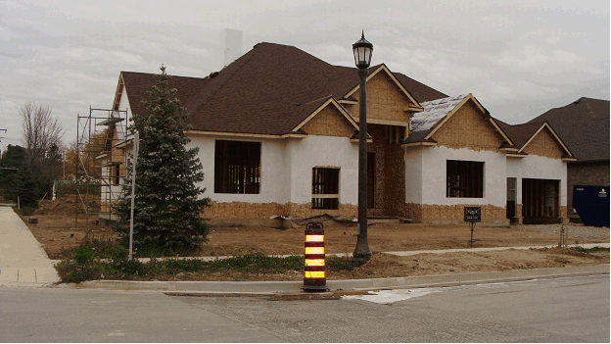

**Figure 2. View of a single detached dwelling located at 1 Angels Drive (across Angels Drive, looking south) that received a minor variance for increased lot coverage to 36.3% for the dwelling.**

The proposed Zoning By-Law Amendment is consistent with existing approvals and does not pose significant concerns from a planning perspective. The change is not anticipated to impact neighbouring properties, including residential properties along the north side of Warner Road and the east side of Tanbark Road in the vicinity of this development, although the massing, lot coverage and character along Angels Drive and in the Fiorucci Estates Subdivision, more broadly, is anticipated to be quite different from existing single detached dwelling properties located along Warner Road, in particular.

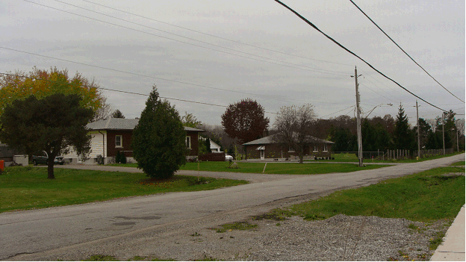

**Figure 3. View of a typical portion of Warner Road neighbouring (across Warner Road) Fiorucci Estates.**

**CONCLUSION**

The applicant is proposing to amend the Zoning By-Law (Section 9.13.16 (h), R1-16) to allow for a maximum lot coverage of 40% including all buildings, up from the currently allowable 33% maximum lot coverage including all buildings for Lots 1, 2, 7, 8, 9, 10, 11, 13, 15, 16, 17, 18, 32, 33 and 34 on Registered Plan 30M-397 (Fiorucci Estates).

The proposed Zoning By-Law Amendment is to amend the site specific zoning for lots contained in Fiorucci Estates (Section 9.13.16.1 (h), R1-16) from a maximum lot coverage of 33% including all buildings to a maximum lot coverage of 37% including all buildings without attached covered porch and deck, and a maximum lot coverage of 40% including all buildings with attached covered porch and deck.

The proposal is consistent with the Provincial and Regional land use planning policies and Planning Staff recommends that the draft Zoning By-Law Amendment attached to the CDS Report be approved.

**Respectfully submitted,**

**Caleigh McInnes Shirley Cater, MCIP, RPP, EcD**

**Contract Planner Manager of Planning**

**John Henricks, MCIP, RPP   
Director of Community   
& Development Services**